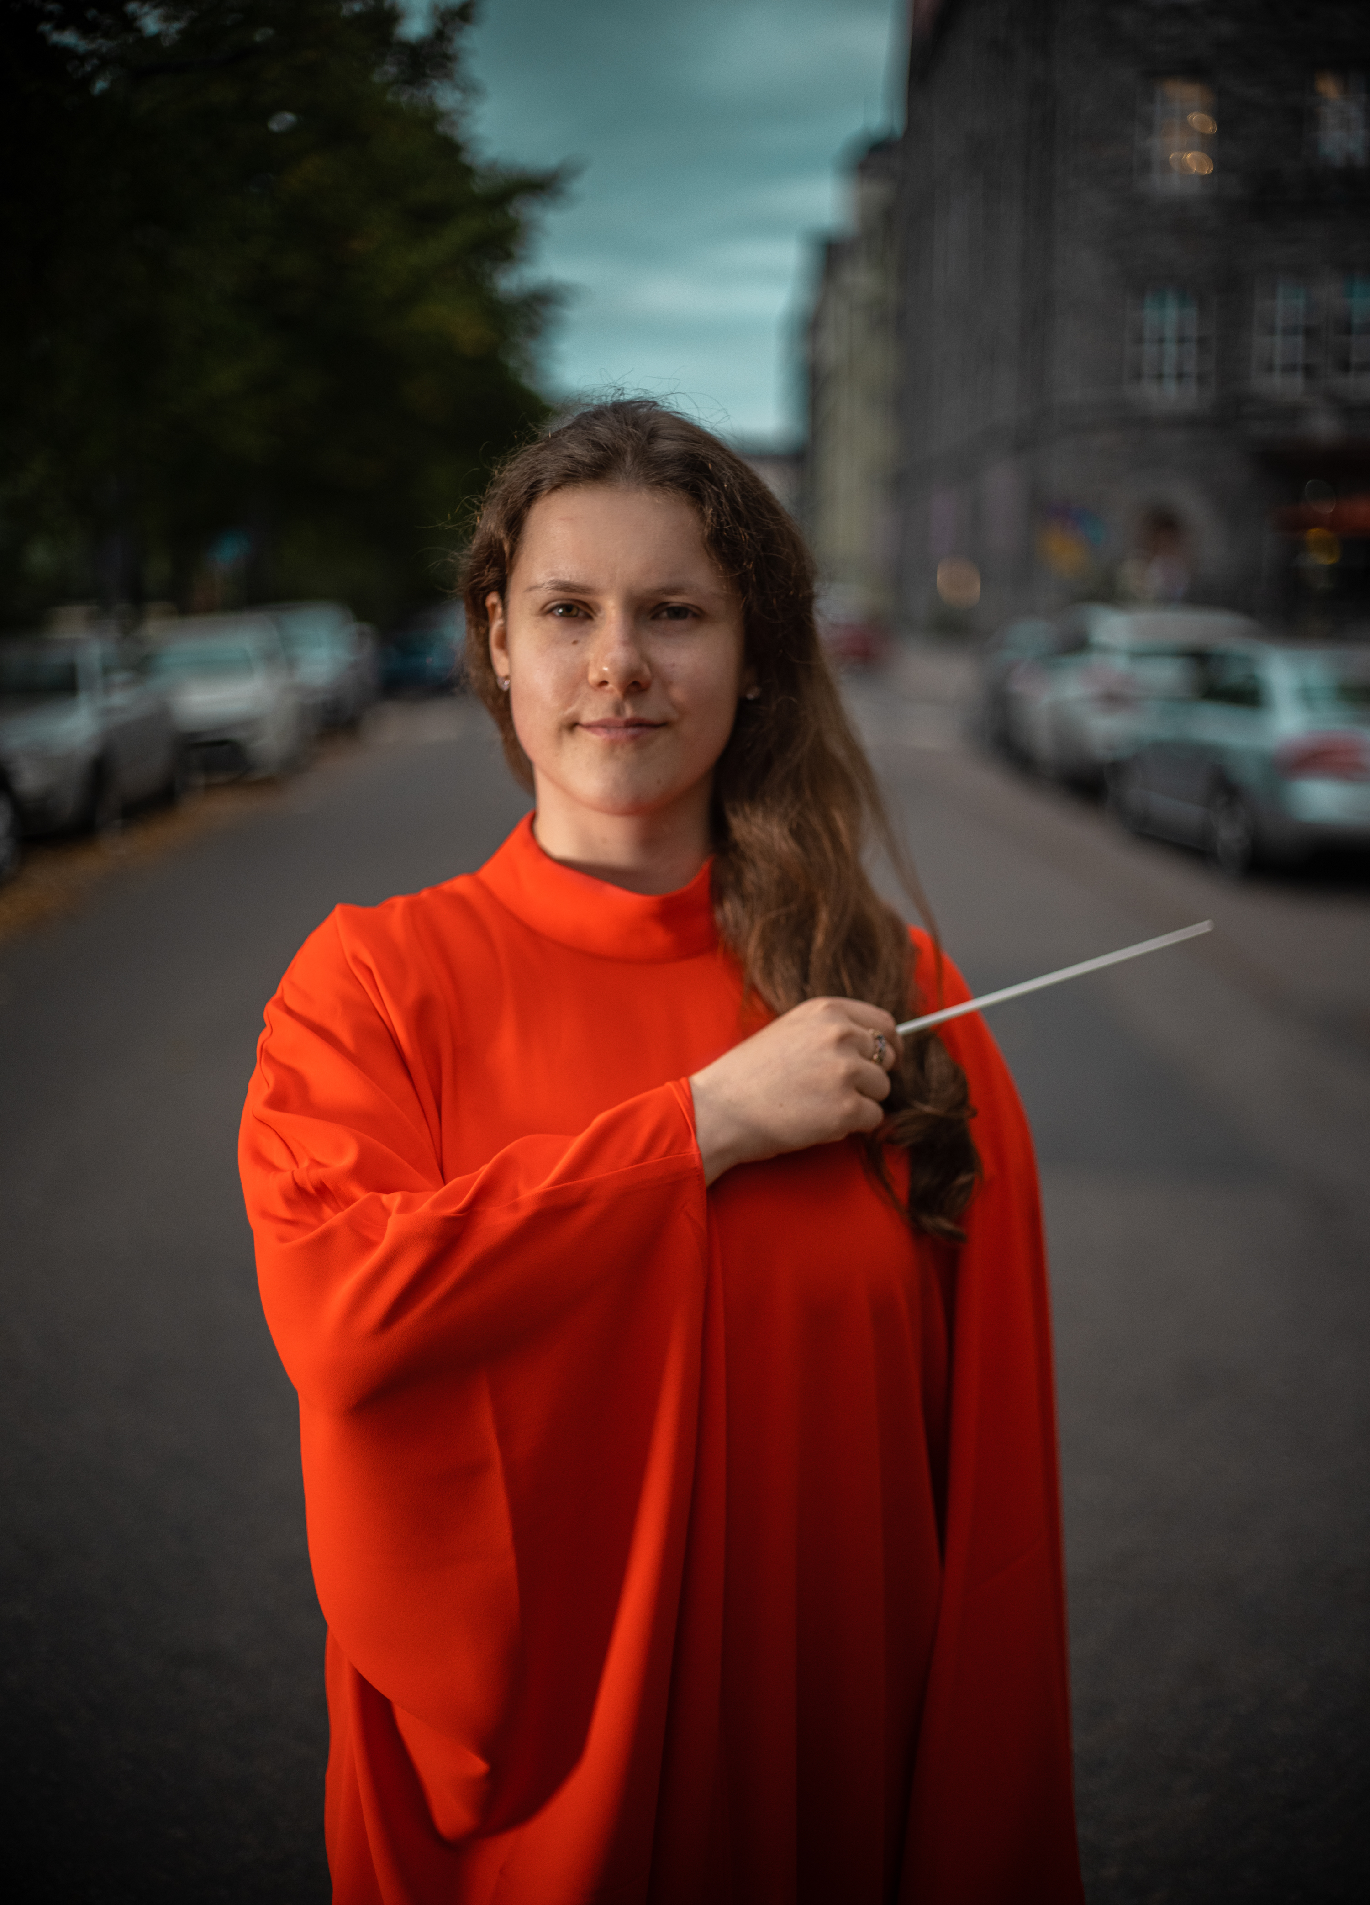
CURRICULUM VITAE – ERLE KONT

“Erle has everything!“
Paavo Järvi

„Kont drew an intensely moving slow movement
and conjured up a sparklingly vital finale“
Hufvudstadsbladet newspaper

„Kont got the orchestra to play with burning passion
and charming warmth. A great promise!“
Aamulehti newspaper

“Conductor Kont brought out a rich palette of orchestral colors
from the Pori Sinfonietta“
Satakunnan Kansa newspaper

UPCOMING CONDUCTING ENGAGEMENTS

2025 Tapiola Sinfonietta (re-invitation) – Pärt, Adams, Cage, Byrd
Joensuu City Orchestra (re-invitation)
Kirkkonummi Chamber Orchestra (debut)

2024 Lahti Symphony Orchestra (re-invitation) – Blake
Jyväskylä Sinfonia (re-invitation) – Blake
Seinäjoki City Orchestra (debut, Artist In Focus) –
Mahler, Kont, Debussy, Shostakovich

CONDUCTED PROFESSIONAL ORCHESTRAS

2024 Tampere Philharmonic Orchestra - Sibelius
Turku Philharmonic Orchestra - Sibelius, Copland, Gorecki
Lappeenranta City Orchestra - Klami, Haydn, Rantala, Beriot
Orquesta Sinfonica del Principado de Asturias -
Rimsky-Korsakov, Mozart
Allegra Festival Orchestra – Dvorak, Mozart, Brahms

2023 Helsinki Philharmonic Orchestra – Mielck
Finnish Radio Symphony Orchestra – Mendelssohn, Brahms
Lahti Symphony Orchestra – Britten, Rimsky-Korsakov
Joensuu City Orchestra – Mahler, Mussorgsky
Jyväskylä Sinfonia – Mahler, Mussorgsky
Ploiesti Philharmonic Orchestra – Mendelssohn, Bartok
Helsinki Cellofest Orchestra – Vivaldi, Tchaikovsky, Lanzetti

2022 BBC Scottish Symphony Orchestra – Elgar, Bartok
Tapiola Sinfonietta – Poulenc
Jyväskylä Sinfonia – Mozart
Joensuu City Orchestra – Beethoven
Oulu Sinfonia – Johann Strauss I
Pori Sinfonietta – Prokofiev, Beethoven
2021 Tapiola Sinfonietta - Beethoven
Vaasa City Orchestra – Schumann
Joensuu City Orchestra – Prokofiev
EDUCATION

2021 – 2024 Sibelius Academy, symphony orchestra conducting Masters
degree, Sakari Oramo
2020 – 2021 Sibelius Academy, wind orchestra conducting Masters degree,
Petri Komulainen
2014 – 2020 Sibelius Academy, clarinet Bachelors and Masters degrees,
Kari Kriikku and Harri Mäki

CONDUCTING MASTERCLASSES

Esa-Pekka Salonen, Paavo Järvi, Neeme Järvi, Jukka-Pekka Saraste, Eva Ollikainen, Jorma Panula, Johannes Schlaefli, Nicolas Pasquet, Dalia Stasevska, Antony Hermus, Bjarte Engeset, Nicholas Collon, Leo McFall, James Gaffigan and others.

FOUNDER AND ARTISTIC DIRECTOR
TARTU SOUND

Kont is the founder and artistic director of the contemporary music organisation Tartu Sound (2017), which unites composers, musicians and audience members from Tartu region, Estonia. Tartu Sound helps young composers start their professional careers by organising concerts of their music. The organisation works with musicians of the highest caliber from Estonia and internationally such as Ensemble Itineraire (2021), Finnish based Far(away) Ensemble consisting of musicians, dancers and a choreographer (2019) and the Icelandic composer and double bassist Bara Gisladottir (2018).

CLARINET

AWARDS

2015 1st prize in Bohuslav Martinu competition in ISA festival
1st prize in Viktor Kalabis competition as a duo in ISA festival

2013 - 2014 2nd prize in international Eduard Medinš competition among
woodwinds
2nd prize in Estonian Music Highschools competition among
clarinetists

2012 3rd prize in Estonian Music Highschools competition among
woodwinds

2011 2nd prize in international Eduard Medinš competition among
woodwinds
1st prize in Estonian young clarinetists competition

2010 1st prize in international Eduard Medinš competition among
woodwinds
2009 1st prize in Estonian young clarinetists competition
1st prize in David Otto Wirkhaus clarinet competition

